

**SOFTWARE ENGINEERING V20**

Sequence Diagram

Activity Diagram

State Diagram

Gantt Chart

**Section:**

V20

**Name:**

Noor Ul Huda (F2023266853)

Khuzaima Tajammal (F2023266890)

Nimra Maqbool (F2023266852)

**Sequence Diagram:**

|  |  |
| --- | --- |
| **Category** | **Details** |
| **General Requirements** | Ease of Use: User-friendly system Accessibility: Wide usability Reliability: Consistent performance Scalability: Supports growth |
| **Functional Requirements** | Facial Recognition Attribute Recognition Re-identification Real-Time Alerts Database Integration Reporting & Analytics |
| **Performance Requirements** | Accuracy: At least 98%  Response Time: Fast processing Fault Tolerance: Handles failures |
| **Hardware Requirements** | Surveillance Cameras Computing Power Storage Networking |
| **Software Requirements** | AI Algorithms  Facial Recognition Libraries |

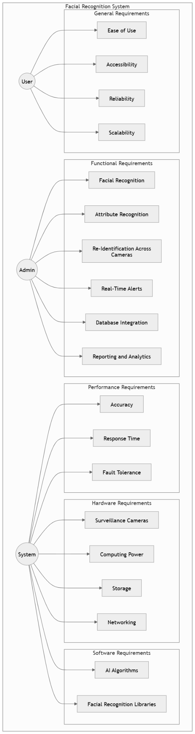

**Activity Diagram:**

|  |  |  |  |  |  |  |  |  |  |
| --- | --- | --- | --- | --- | --- | --- | --- | --- | --- |
| | **Component** |  |  |  |  | | --- | --- | --- | --- | --- | | **Requirement Type** | **Details** | **Risk** | **Verification Method** |
| **General Requirements** | Usability, Accessibility  Reliability, Scalability | Simple interface, platform availability (web and mobile), consistent and accurate results  System must handle growing demands and maintain consistent performance | Low or Medium or High  Medium  Or High | Inspection, Analysis, Test  Test |
| **Functional Requirements** | Facial Recognition  Real-Time Alerts  Database Integration | Identify individuals accurately using tools like OpenCV, TensorFlow, AWS Rekognition  Notifications based on specific events  Effective storage and retrieval | High  Medium or high  Medium | Test  Analysis  Test |
| **Performance Requirements** | Accuracy, Response Time  Fault Tolerance | Achieve 98% accuracy and provide quick feedback  Operate smoothly despite partial system failures | High  high | Analysis, Test  test |
| **Hardware Requirements** | Surveillance Cameras  Computing Power | Capture images for processing  AI and processing support | Medium  high | Inspection  Analysis |
| **Software Requirements** | AI Algorithms  Prebuilt Libraries | For facial recognition,  feature extraction  Use libraries like facial recognition SDKs | High  Medium  Or  high | Test  Demonstration |

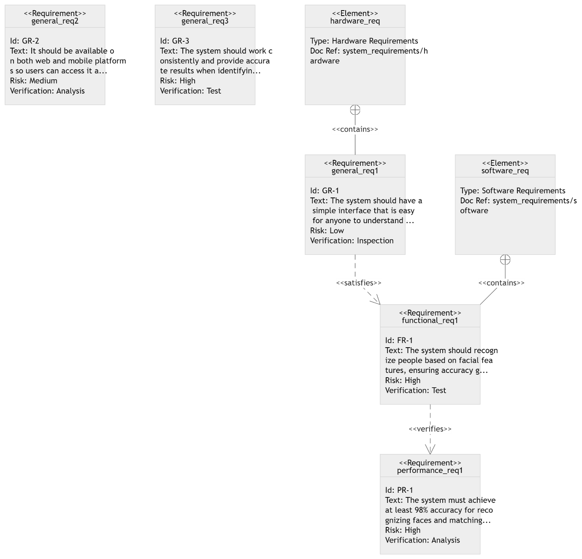

**State Diagram:**

|  |  |  |  |
| --- | --- | --- | --- |
| | **Category** | | --- | | | **Details** | | --- | |
| |  | | --- | | **General Requirements** |  |  | | --- | |  | | - Ease of Use, Accessibility, Reliability, Scalability |
| **Functional Requirements** | |  | | --- | |  |  |  | | --- | | - Facial & Attribute Recognition - Real-Time Alerts - Reporting & Analytics | |
| |  | | --- | | **Performance Requirements** |  |  | | --- | |  | | - Accuracy, Response Time, Fault Tolerance |
| |  | | --- | | **Relationships** | | |  | | --- | | - General ↔ Functional: Implementation tied to usability - Functional ↔ Performance: Metrics depend on core functions | |

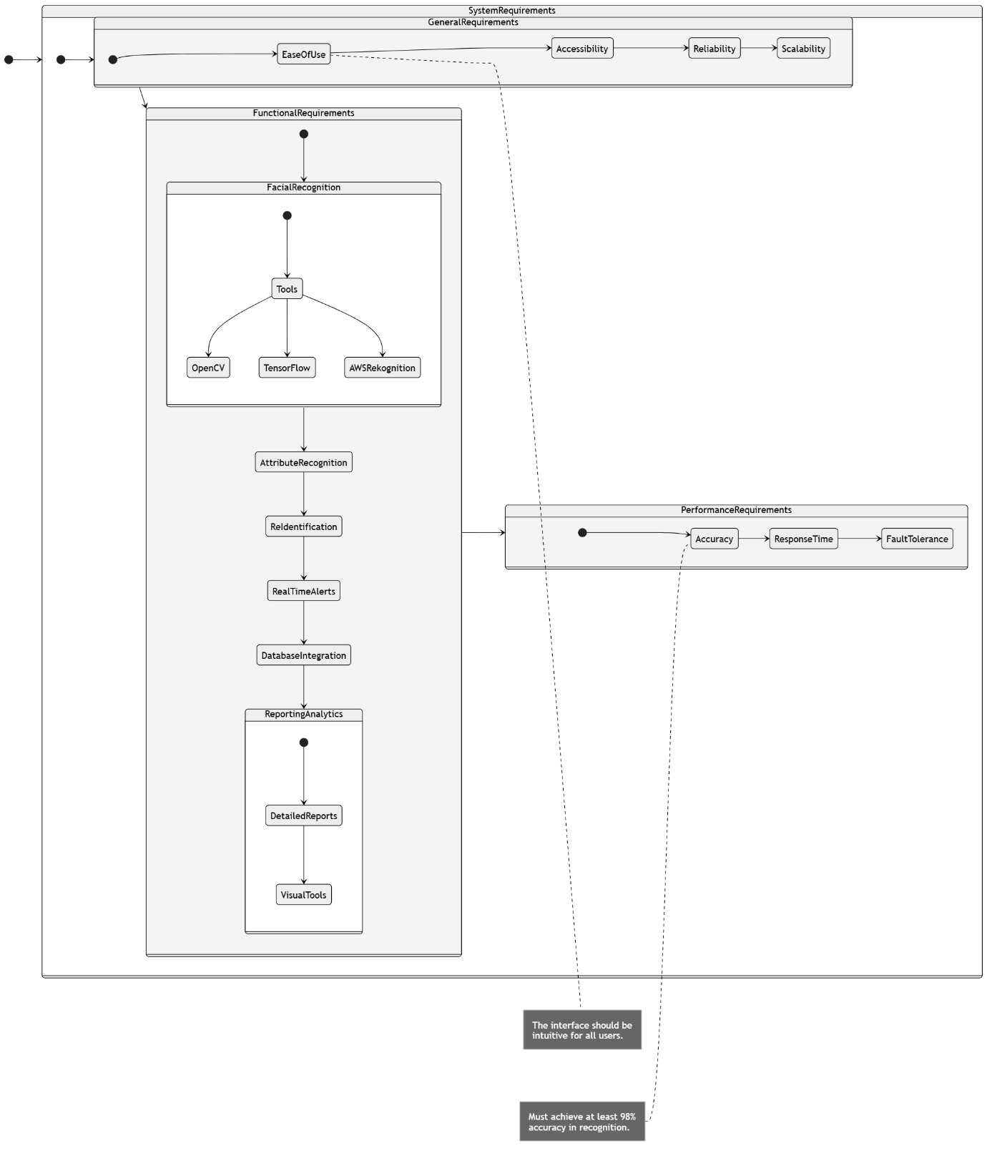

**Gantt Chart:**

**Phases & Timelines:**

* Requirement Gathering starts on Feb 04 and ends on Feb 08, handled by Team A (represented in blue).
* Design phase runs from Feb 09 to Feb 15, managed by the Design Team (green).
* Development takes place from Feb 16 to Feb 25, with work done by the Dev Team (brown).
* Testing occurs between Feb 26 and Mar 04, led by the QA Team (red).
* Deployment follows from Mar 05 to Mar 09, handled by the Ops Team (purple).
* Post-Deployment spans Mar 10 to Mar 12, managed by the Support Team (cyan).

**Key Milestones:**

* Design Approval is set for Feb 11, marked with an X and labeled accordingly.
* Code Freeze happens on Feb 25, also marked with an X to indicate the end of active development.
* Launch takes place on Mar 10, symbolized by an X, signifying the official system release.

**Additional Chart Elements:**

* Milestone Markers: ‘X’ symbols are used for important checkpoints like Design Approval, Code Freeze, and Launch.
* Progress Indicators: The chart shows overlapping tasks and progression from one phase to another.
* Team Labels: Each phase includes a note indicating which team is responsible.
* Color Legend: A color-coded legend differentiates phases for clarity.

